The Title of the Manuscript
First Author ª, Second Author ^{b} , Third Author ^{c}
ª Department, College, University, City, Country.
^{b} Department, College, University, City, Country.
^{c} Department, College, University, City, Country.

A R T I C L E IN F O A B S T R A C T
The abstract is a short summary of the article. It should be between 150 words and written in one paragraph. The abstract must include the purpose of the study, methods, main results, and conclusion. Do not include references, abbreviations, or figures.

Keywords:
Carefully select an appropriate list of five keywords that represents the
real content of your paper

- INTRODUCTION
This template is prepared for the Journal port Science Research. It gives authors the main formatting rules needed to prepare their papers in electronic form. The purpose of these rules is threefold: (a) to make it easier for authors to format their manuscripts, (b) to ensure that the electronic version is ready for online publication, and (c) to keep a uniform style for all papers published in the journal.
Margins, line spacing, and text styles are already defined in the template. Examples of font styles and formatting are shown in this document in italic text. Some elements, such as complex equations, figures, or tables, are not fixed by the template, but the general style for table text is provided. Authors should prepare these parts by following the same format guidelines.
- EASE OF USE
2.1. Selecting a Template
Please make sure that you are using the correct template for your paper size. The template of the Journal is designed for A4 paper size. If you are working with US Letter size, you should close this file and download the version prepared for Letter size.
2.2. Maintaining the Integrity of the Specifications
This template is provided to help you format your paper correctly and to keep a consistent style. All margins, line spacing, and font types are already defined, so please do not change them. You may notice some unusual settings, such as the head margin being larger than usual. These settings are intentional, because the paper will appear as part of the journal, not as a stand-alone document. For this reason, do not modify any of the current specifications.
2.3. Page Setup and Fonts
- Please use Times New Roman font throughout the manuscript.
- The main text should be in 10 pt size.
- Titles of sections (e.g., INTRODUCTION, METHODS) should be in 10 pt bold. With capital litters
- If subsections are needed, they should be numbered hierarchically (e.g., 1.1, 1.2, etc.). The subsection titles must be written in bold, with only the first letter of each major word capitalized (Title Case).
Examples 1.1. Study Design or 4.2. Data Analysis etc..
- The title of the article should Calibri (Body) be in 18 pt bold.
- Abstract and keywords should be in 10 pt font size.
- Use 1 line spacing and justify all paragraphs.
- Margins should be set to 2.5 cm (1 inch) on all sides.
- The manuscript should be formatted in two columns with a 0.32 cm space between the columns.

2.4. Figures and Tables
In the Results section, authors should present their data clearly using tables and figures, as this is one of the most important parts of a research paper. Tables and figures must be prepared in a simple, accurate, and effective way. The planning for them often starts at the manuscript writing stage.
When using tables and figures, do not repeat information that is already explained in the text. Repetition makes the paper unnecessarily long and reduces the value of the tables and figures. Each table and figure should be placed at the center of the page, properly numbered, and cited in the order in which they appear in the text.
Since readers often look at tables and figures before reading the full text, each of them should be able to stand alone, providing complete and informative content by itself.
2.4.1. Figures
Figures are often used to illustrate ideas in the form of graphs, photographs, or charts. In technical papers, photographs are usually included to show experimental equipment, but they should only be used if they add real value to the explanation. Otherwise, a schematic drawing may be more effective.
Charts and graphs present the same data that could be shown in tables, but in a more visual and interesting way. However, unlike tables, they may provide less detail or precision.
- Each figure must have a caption placed below the figure,
- The caption should be written in Times New Roman, 9 pt, italic,
- The figure number (e.g., Figure 1) should be in bold, figures must be numbered sequentially (Figure 1, Figure 2, etc.),
- leave one line space before and after the figure
- Each figure must be enclosed within a clear border (frame).
- Place each figure at the center of the page.
- Graphs usually has x and y axes that must be associated with labels. Be sure to add sufficient information into the label but try not to get too much into it, for example, Average Speed (cm/sec).
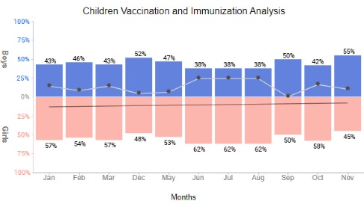
Figure 1 : Trends in patient data usage over time
- A Figures must be of high quality. The preferred format is TIFF, with a minimum resolution of 500 dpi at final size. Higher resolutions, such as 600 dpi, can be used if needed, but they will increase the file size. Scaling may be adjusted when necessary.
- Color figures are encouraged, but TIFF files containing color should be prepared in sufficiently large size to maintain clarity. All letters, numbers, and symbols in the figures must be easy to read and appropriately sized.
- Color figures are encouraged, but TIFF files containing color should be prepared in sufficiently large size to maintain clarity. All letters, numbers, and symbols in the figures must be easy to read and appropriately sized.

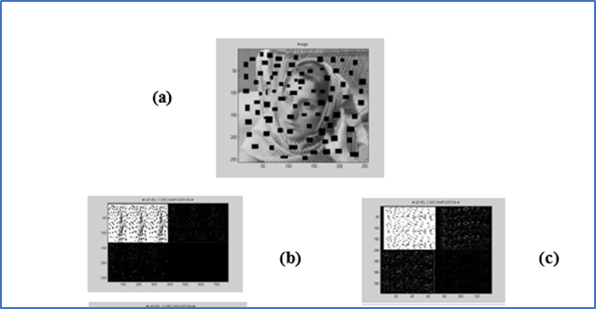

Figure 6: a) The lost block image, b) the first level of decomposition, c) the second level of decomposition,

2.4.2. Table Titles
Tables should be clear, well-structured, and easy to understand without the need to read the main text. They are especially useful for presenting large sets of numerical data obtained from multiple experiments, where a graph may not be sufficient. Such tables are often called quantitative tables, as shown in Table 1 (adapted from [1]).
Authors should prepare tables using standard tools such as the Microsoft Word table function. Tables must not be inserted as images. Each table should include the following basic elements: a clear caption, properly labeled column titles, and a well-organized body.
- The table caption should be placed above the table. It must include the table number in bold followed by the title in italic, written in Times New Roman, 9 pt.
- The table content should be in Times New Roman, 9 pt, single-spaced, and neatly formatted.
- Single-spaced, and clearly formatted.
- The first row, which contains the main variables, should be written in bold.
- If the first column contains variables, they should also be written in bold.

Table 1: Descriptive statistics of the study population.
Model | AUC | Accuracy | F1 | Precision | Recall | MCC
Random Forest | 0.861 | 0.785 | 0.78 | 0.799 | 0.762 | 0.571
SVM | 0.861 | 0.782 | 0.778 | 0.794 | 0.762 | 0.564
KNN | 0.85 | 0.777 | 0.772 | 0.789 | 0.756 | 0.554
Gradient Boosting | 0.851 | 0.774 | 0.769 | 0.787 | 0.752 | 0.549

2.5. Equations
Equations are an exception to the general template specifications. Authors should type equations using Times New Roman or Symbol font only (do not use any other fonts). For complex multi-level equations, it may be necessary to prepare them as graphics and insert them into the text after formatting.
Equations must be numbered consecutively. The equation number should be placed flush right in parentheses, for example (1). Equations should be centered on the page.
When writing equations:
- Italicize Roman symbols for quantities and variables, but not Greek symbols.
- Use a long dash (–) for a minus sign, not a hyphen.
- Punctuate equations with commas or periods if they are part of a sentence.

Example:
${\left(x+a\right)}^{n}=\sum_{k=0}^{n}{\left({n \atop k}\right)x^{k}a^{n-k}}$ (1)
Always define symbols used in an equation either before or immediately after the equation. Use “(1)” in the text, not “Eq. (1)” or “equation (1),” unless it appears at the beginning of a sentence, e.g., “Equation (1) shows that …”.
Conflicts of Interest
The authors should pledge that they don’t have any conflict of interest in regards of their research. If there are no conflict of interest then authors can declare the following "The authors declare no conflicts of interest".
Funding
The funding section of your journal paper template should provide a concise and transparent declaration of the financial support received to carry out the research presented in your paper.
Acknowledgment
The preferred spelling of the word “acknowledgment” in America is without an “e” after the “g”. Avoid the stilted expression “one of us (R. B. G.) thanks ...”. Instead, try “R. B. G. thanks...”. Put sponsor acknowledgments in the unnumbered footnote on the first page.

REFERENCES
Journal port Science Research, follow the APA format (7th edition) . In APA format (7th edition), Cite inside the text. Just write the author’s last name and year.
Example:
Mathematics is fundamental in science (Smith, 2020).
Smith (2020) proved that the module is injective.
Write the reference at the end (References)
Book
Smith, J. (2020). Introduction to algebra. Springer.
Article
Smith, J. (2020). Injective modules over rings. Journal of Algebra, 45(2), 123–135.
Reference list (APA style)
Note: In APA, references are usually not numbered.

Examples:
Smith, J. (2020). Introduction to algebra. Springer.

Anderson, F. W., & Fuller, K. R. (1992). Rings and categories of modules. Springer.

American Psychological Association. (2020). APA style guidelines. https://apastyle.apa.org

E-mail address: Corresponding* : xxxx Emai1@ uoitc.edu.iq. ª Emai2@il.edu ^{b} Emai3@gmail.com^{c} Received 00th January 20xx, Accepted 00th January 20xx  ^{10.36371/port.2026.2.1} 

